The Engineering Design Process
Day 8: Lesson Quiz
Choose the letter of the best answer.

1. Which of the following is not a skill an engineer would use to design a bridge?
A. creative thinking
B. methodical thinking
C. using math and models
D. designing a controlled experiment
2. What is the correct order of steps to follow in the engineering design process?
A. report the results; identify a need; carry out research and brainstorm solutions; build and test a prototype
B. identify a need; carry out research and brainstorm solutions; build and test
a prototype; report the results
C. build and test a prototype; report the results; identify a need; carry out research and brainstorm solutions
D. carry out research and brainstorm solutions; build and test a prototype; report the results; identify a need
3. An engineer is designing a robot. The engineer builds the first robot to test and troubleshoot problems for future robots. What is the first test robot called?
A. a model
B. a prototype
C. a computer
D. an application
4. Which of the following is the best definition of engineering?
A. the study of the natural world
B. the application of science for practical purposes
C. the application of science and mathematics
to solve real-life problems
D. the use of tools, machines, materials, and processes to meet human needs
5. The Venn diagram below shows the relationship between science, technology, mathematics, and engineering.
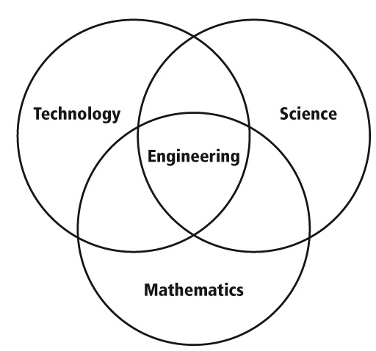
According to this diagram, which statement best describes this relationship?
A. Engineering uses only science and technology to solve problems.
B. Engineering uses only science and mathematics to solve problems.
C. Engineering uses only mathematics and technology to solve problems.
D. Engineering uses science, mathematics, and technology to solve problems.

